NORTHWESTERN STATE UNIVERSITY
AND
LOUISIANA COMMUNITY & TECHNICAL COLLEGE SYSTEM (LCTCS) AND MEMBER COLLEGES
Memorandum of Understanding for Consideration of Reduced Tuition
BACKGROUND: The success of higher education in Louisiana depends on the various institutions and systems working together to achieve the common goal of enhancing the quality of life for the citizens of our State. Northwestern State University (NSU) and Louisiana Community & Technical College System (LCTCS) and Member Colleges, provide higher education opportunities to the citizens of Louisiana and beyond. LCTCS has evolved and expanded to fulfill the technical training needs of the region; to continue that evolution will require that LCTCS provide on-going professional development and advanced educational opportunities to its faculty and staff. To that end, NSU offers undergraduate and graduate programs that LCTCS: Board Office and Member Colleges faculty and staff need in order to meet credentialing standards set by programmatic, regional, and national accreditation agencies.
The LCTCS Board Office, and Member Colleges, included in this request are: Baton Rouge Community College, Bossier Parish Community College, Central Louisiana Technical Community College, Delgado Community College, Fletcher Technical Community College, Louisiana Delta Community College, Northshore Technical Community College, Northwest Louisiana Technical Community College, Nunez Community College, River Parishes Community College, South Louisiana Community College, and SOWELA Technical Community College.
Both NSU and LCTCS have a shared mission to enhance the quality of life for Louisiana's citizens; enhancing the academic preparation of LCTCS personnel helps to ensure a better prepared workforce and promotes economic development in Louisiana. Therefore, NSU seeks to assist LCTCS in its efforts to promote on-going professional development and advanced educational opportunities to its faculty and staff by providing certain tuition waiver benefits to qualified LCTCS employees who wish to enroll at NSU. {This agreement will replace other agreements NSU has with individual LCTCS Colleges.)
The following conditions will apply to LCTCS employees who seek the NSU tuition benefit below: be employed on a full-time basis at LCTCS Board Office or one of the Member Colleges,
- submit an application for admission to NSU and pay the appropriate application fee,
- meet admission requirements for NSU,
- take courses for credit; fees will not be waived for audit classes,
- adhere to NSU policies and procedures,
- submit a signed and completed copy of this form for each semester in which the benefit is requested,
- pay account balances in full each semester.
LCTCS employees who meet all requirements listed above may:
- Register for up to six (6) hours per semester for a reduced charge per credit hour of no less than $25/credit hour for both graduate and undergraduate coursework.
- Be responsible for all state and federally required fees including fees approved by the Board of Supervisors for the University of Louisiana System.
- The tuition benefit shall apply only to courses and programs not available at LCTCS and for which regular tuition is charged. The tuition benefit may not be used in combination with any other discounted program.
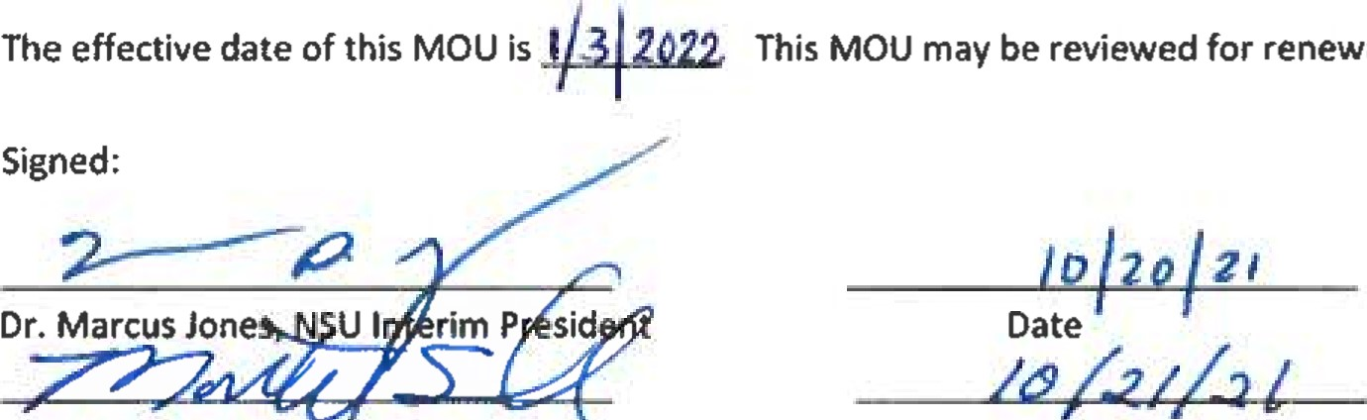
al periodically.
Date
APPLICATION FOR NSU TUITION BENEFIT LCTCS EMPLOYEES

This form must be submitted for each semester in which the tuition benefit is requested. Submit a copy with signatures at least three weeks prior to the beginning of each semester to:

Northwestern State University, Provost & VPAA
Caspari Hall, Room 211
Natchitoches, LA 71497
Please type or print.
Place of employment:

Employee's Name (Last, First Ml)

Employee ID NSU Student ID

Degree pursued (e.g., BA, BS, MS, or MA) Major (e.g., Accounting, English, Mathematics)

Semester to Apply Benefit:
Fall SPRING SUMMER I SUMMER II YEAR
Subject and Course Number (e.g., BIOL 3307) | Credit hours | CRN (e.g., 40098)
The following conditions will apply to employees who seek the NSU tuition benefit below. The employee must:
- be employed on a full-time basis at the LCTCS location identified above,
- submit an application for admission to NSU and pay the appropriate application fee,
- meet admission requirements for NSU,
- take courses for credit; fees will not be waived for audit classes,
- adhere to NSU policies and procedures,
- submit a signed and completed copy of this form for each semester in which the benefit is requested,
- pay account balances in full each semester
Employees who meet all requirements listed above may:
- Register for up to six (6) hours per semester for a reduced charge per credit hour of no less than $25/credit hour for both graduate and undergraduate coursework.
- Be responsible for all state and federally required fees including fees approved by the Board of Supervisors for the University of Louisiana System.
- The tuition benefit shall apply only to courses and programs not available at LCTCS and for which regular tuition is charged. The tuition benefit may not be used in combination with any other discounted program.
certify that I meet all criteria and agree to the terms specified above.

Employee Signature Date

Employer Director of Human Resources Signature Date

NSU Provost & VPAA Signature Date

